Lesson 4 – LINE GRAPH
1. Introduction (1 câu)
Mục tiêu: Paraphrase lại đề bài.
Template:
The line graph illustrates the number of / the amount of / the percentage of + (đối tượng) + over the period from (năm bắt đầu) to (năm kết thúc).
Lưu ý:
- Không thêm số liệu
- Không mô tả xu hướng
- Chỉ viết lại đề bằng từ ngữ khác
VD: The graph below shows the percentage of people using the Internet in three countries between 2000 and 2020.
Viết lại:
“The line graph illustrates the proportion of people who used the Internet / Internet users in three nations from 2000 to 2020.
2. Overview (2 câu)
Câu 1: Nêu xu hướng chung của các đường trong biểu đồ: đường nào tăng, đường nào giảm, đường nào giữ nguyên, đường nào dao động)
Câu 2: Nêu điểm nổi bật nhất (đường cao nhất, thấp nhất, tăng mạnh nhất, khác biệt rõ nhất…).
Template:
Câu 1 – Xu hướng chung:
- Overall, it is clear that + [tất cả/đa số các nhóm] + [tăng/giảm/dao động/giữ ổn định] + over the period. (Nếu tất cả giống nhau) (KHÔNG DÙNG TRẠNG TỪ)
- Overall, while [đối tượng A và B] experienced upward trends, [đối tượng C và D] declined over the years. (Nếu có sự khác nhau)
=> an upward trend: xu hướng tăng >< a downward trend: xu hướng giảm (CHỈ OVERVIEW)
Câu 2 – Điểm nổi bật:
- Additionally, [nhóm A] + recorded the highest values.
1. Trường hợp 1 – A cao nhất
“It is also clear that A recorded the highest figures throughout the period (toàn bộ giai đoạn) / during most of the period (hầu hết giai đoạn).”
2. Trường hợp 2 – A cao hơn hẳn những nhóm còn lại (vượt trội)
“It is noticeable that A was far higher than all the other categories.”
3. Trường hợp 3 – A thấp nhất
“It is also clear that A remained the lowest category over the entire timeframe.”
4. Trường hợp 4 – A thấp hơn hẳn các nhóm còn lại (thấp vượt trội)
“It is also clear that A was far lower than the other groups.”
5. Trường hợp 5 – A bắt đầu thấp nhất nhưng kết thúc cao nhất
“Another key point is that A, which started with the smallest figure, later became the leading category.”
6. Trường hợp 6 - A có sự thay đổi đáng kể nhất
“A experienced / saw / witnessed / recorded + the most significant change”
nếu nói đến phương tiện / nơi chốn … được người ta lựa chọn nhiều nhất, có thể sử dụng:
X was the most popular means of transport / place… throughout the period
Không dùng số liệu ở phần này.
3. Body Paragraph 1 (4–5 câu)
Mục tiêu: Mô tả chi tiết 1–2 đường đầu tiên.
Cách trình bày:
- Nêu điểm bắt đầu (In + năm đầu)
- Mô tả diễn biến chính
- Nhắc mốc quan trọng hoặc thay đổi đáng chú ý
- Nêu điểm kết thúc
Mẫu câu gợi ý:
- A started at…, which then increased steadily…
4. Body Paragraph 2 (4–5 câu)
Mục tiêu: Mô tả các đường còn lại và thực
hiện so sánh.
Cách trình bày:
- Giới thiệu đối tượng tiếp theo (Regarding the remaining categories)
- Mô tả các thay đổi chính
- Nêu sự khác biệt so với đường ở Body 1
- Kết thúc bằng mốc cuối
KHI BÁO CÁO SỐ LIỆU, NẾU SỐ LIỆU CHƯA CHẠM VÀO MỘT MỐC SỐ TRÒN:
• about (khoảng)
• around (xấp xỉ / khoảng)
• approximately (khoảng / xấp xỉ — trang trọng hơn)
• roughly (xấp xỉ / ước chừng)
• nearly (gần / gần như)
• almost (hầu như / gần như chạm đến)
• just under (ngay dưới / thấp hơn một chút)
• just over (ngay trên / cao hơn một chút)

Practice
The line graph below shows the average carbon dioxide (CO2) emissions per person in the United Kingdom, Sweden, Italy and Portugal from 1967 to 2007.
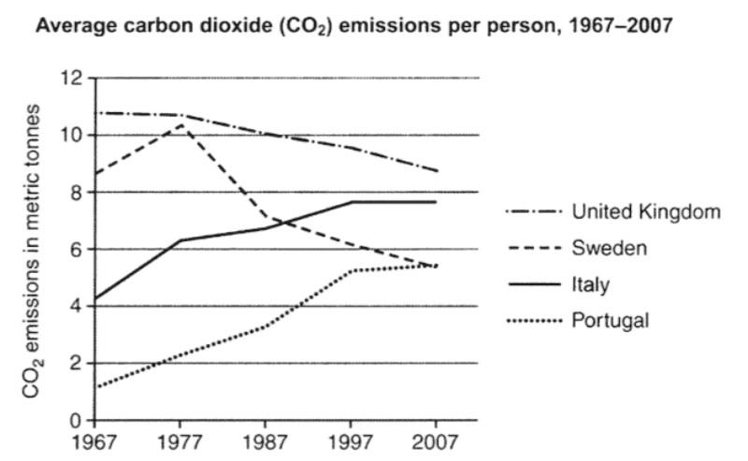
Paraphrase:
“carbon dioxide emissions per person”
• The amount of CO₂ emitted by each person
• the amount of CO₂ each person produced
• carbon dioxide produced per person
• the level of CO₂ per person
• CO₂ output per person
• carbon emissions per person
Nếu trong đề:
- liệt kê từng đối tượng => tóm tắt lại bằng: số + danh từ
- số + danh từ => số + different + paraphrase danh từ
- different / various + danh từ => số + paraphrase danh từ
- số + danh từ => số + different + paraphrase danh từ, namely + liệt kê, from.. to…
Mr. Nam | Băng | Mr. Minh | Linh
The line graph illustrates the amount of CO2 emitted by each person in four European countries from 1967 and 2007 | The line graph illustrates the amount of CO₂ emitted by each person in four nations from 1967 to 2007 | The line graph illustrates the amount of CO2 emitted by each person in four countries from 1967 to 2007. | The line graph illustrates the mount of CO2 each person produced in four different countries from 1967 to 2007
Overall, while carbon dioxide emissions per person in the United Kingdom and Sweden experienced downward trends, the figures for Italy and Portugal increased over the years.  Additionally, It is also clear that United Kingdom consistently recorded the highest figures throughout of the period | Overall, while the amount of CO₂ each person produced in Italy and Portugal experienced upward trends, there were downward trends in the figures for the United Kingdom and Sweden  Additionally, it is also noticeable that the United Kingdom consistentlyrecorded the highest values among four nations. | Overall, while the amount of carbon dioxide produced per person in Italy and Portugal experienced upward trends, the figures for the United Kingdom and Sweden declined over the years  Additionally, the level of CO2 per person in the United Kingdom consistently recorded the highest values throughout the period | Overall, while the amount of CO₂ emitted by each person in Italy and Portugal experience upward trends, the figures for the United Kingdom and Sweden reduced over the years.  Additionally, the amount of carbon dioxide produced per person in the United Kingdom was CONSISTENTLY far higher than all categories throughout the period.
In 1967, The amount of CO₂ each person produced in The United Kingdom stated at roughly 11 metric tonnes, which then reduced steadily to just under 9 metric tonnes in 1997. Meanwhile, the quantity of CO2 each person produced in Sweden recorded a rapid growth from nearly 9 metric tonnes to just over 10 metric tonnes from 1967 to 1977. However, there was a significant reduce to just under 6 metric tonnes in this figure at the end of the period. | In 1967, the amount of CO₂ emitted by each person in the United Kingdom started at just under 11 metric tonnes, which then decreased steadily to approximately 9 metric tonnes in 2007. Meanwhile, The figure for Sweden began at around 9 metric tonnes in 1967 and experienced a sharp rise to its peak of just over 10 metric tonnes in 1977. However, this figure then decreased significantly to just under 6 metric tonnes at the end of the period | In 1967, CO2 emissions in the United Kingdom started at about 11 metric tonnes, which then reduced gradually to around 9 metric tonnes in 2007. Meanwhile, The figure for Sweden rose sharply from about 9 metric tonnes to 10 metric tonnes between 1967 and 1977 before reducing dramatically to above 5 metric tonnes at the end of the period | In 1967, carbon dioxide emissions per person in the United Kingdom started at 11 metric tonnes, and then it reduced steadily to approximately 9 metric tonnes in 2007. Meanwhile, the figure for Sweden experienced a rapid rise from roughly 9 metric tonnes in 1967 to its peak of about 10 metric tonnes in 1977. However, there was a remarkable drop to approximately 6 metric tonnes in this figure in 2007.
Regarding the remaining categories, carbon dioxide emissions per person in Italy experienced a significant climb from around 4 metric tonnes to just under 8 metric tonnes over the period from 1967 to 1997 and then it remained unchanged until 2007. Similarly, The figure for Portugal rose considerably from above 1.5 metric tonnes to approximately 5 metric tonnes in 1997. After that, there was a stability in this figure by the end of the period. | Regarding the remaining categories, Italy and Portugal both showed upward trends. Italy started the period with approximately 4 metric tonnes in 1967, which then climbed steadily to just under 8 metric tonnes over the next 30 years, before remaining unchanged until 2007. Similarly, the amount of CO₂ emitted by each person in Porgutal increased steadily from just over 1.5 metric tonnes in 1967 to approximately 5.5 metric tonnes in 1997. After that, This figure remained unchanged by the end of period | Regarding the remaining categories,  There was a significant increase from above 4 metric tonnes to approximately 8 metric tonnes in the amount of CO2 produced per person in Italy between 1967 and 2007 before remaining unchanged by the end of the period . Similarly, C02 emissions in Portugal climbed rapidly from the lowest emission at around 1 metric tonnes in 1967 to 5 metric tonnes. Following that, the figure remained stable until 2007 | Regarding the remaining categories, the amount of CO₂ emitted by each person in Italy climbed sharply from roughly 4 metric tonnes to about under 8 metric tonnes between 1967 and 1997. Following that, it remained unchanged (at under 8 metric tonnes) by the end of the period. Similarly, the figure for Portugal saw a rapid rise from qpproximately 1.5 metric tonnes to roughly 5 metric tonnes between 1967 and 1997. After that, it remained stable by the end of the period.


Note:
- Cao nhất trong số bao nhiêu đối tượng : AMONG
- luôn cao nhất / luôn thấp nhất: CONSISTENTLY + V / ADJ
- Giữ nguyên không đổi: remained unchanged
- remained unchanged + UNTIL + năm cụ thể
- remained unchanged + BY the end of the period (cuối giai đoạn)

Practice 2:
The graph below shows the quantities of goods transported in the UK between 1974 and 2002 by four different modes of transport.
Summarize the information by selecting and reporting the main features, and make comparisons where relevant.”
quantity (n) số lượng (dùng cho cả N đếm được và không đếm được) => không dùng chỉ số lượng người
goods (u/n): hàng hoá (không đếm được) = commodities = freight
~ product (c/n): sản phẩm (đếm được)
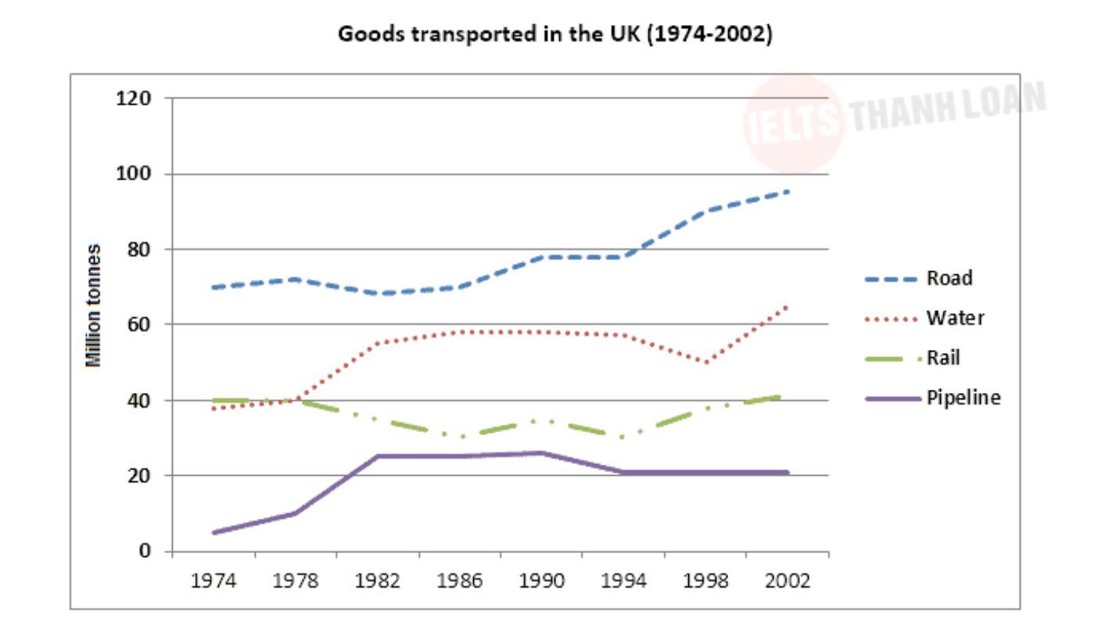

Paraphrase:
the amount of goods transported by rail /road/water/pipeline = Road / Rail/…. transport
the amount of goods carried by rail /road/water/pipeline

the amount of freight moved by rail /road/water/pipeline
Nếu đề mà dùng Danh từ tổng hợp được các đối tượng trong biểu đồ:
- con số + danh từ đó => different / various + danh từ đó paraphrase
- different + danh từ đó => con số + danh từ đó paraphrase
- con số + different + danh từ đó => liệt kê luôn từng đối tượng ra / con số + danh từ đó paraphrase, namely + liệt kê từng đối tượng,...
MODES OF TRANSPORT = MEANS OF TRANSPORT = KINDS / TYPES OF TRANSPORT
Overview: Câu 1 ok. Câu 2: Additionally, road transport consistently recorded the highest values, whereas pipeline was the least popular modes of transport throughout the period.
Body: Khi đã báo cáo hết 1 đối tượng, muốn chuyển đối tượng khác: DÙNG TỪ NỐI
- 2 đối tượng tương phản: By contrast / In contrast
- 2 đối tượng tương đồng: Similarly / Likewise
- 2 đối tượng không tương đồng, không tương phản: Meanwhile
Băng | Linh | Mr. Nam | Mr. Minh
The line graph illustrates the amount of goods transported in the UK by four means of transport, namely road, water, rail and pipeline, over the period from 1974 to 2002.  Overall, while the quantities of goods transported by road, water and pipeline experienced upward trends, the figure for rail fluctuated over the years. In addition, it is also noticeable that the amount of goods transported by road was far higher than all the categories.  In 1974, the amount of goods transported by road started at 70 million tonnes, which then increased steadily to around 75 million tonnes in 1978 before dropping slightly to just under 70 million tonnes in 1982. After that, this figure witnessed a significant growth to nearly 80 million tonnes in 1990, after which it remained stable until 1994 before experiencing a sharp rise to reach approximately 95 million tonnes in 2002. Similarly, the amount of goods transported by water increased subtantially from just under 40 to around 55 million tonnes between 1974 and 1982 before this figure stayed constant for over a decade. Following that, it falling significantly to 50 million tonnes in 1998 and then rise to 65 million tonnes in 2002.  Regarding the remaining categories, the amount of goods trransported by rail started at exactly 40 million tonnes in 1974, after which it went down slightly and hit its lowest point of approximately 30 million tonnes in 1994. However, it then grew again and finished at just over 40 million tonnes in 2002. By constant, pipeline transport experienced a steady climb from just about 5 million tonnes in 1974 to roughly 25 million tonnes in 1982, after which it stayed stable at this level until 1990. After a marginal drop to around 20 million tonnes, this figure remained stable by the end of the period. | The line grapph illustrates the amount of goods transported in the UK from 1974 to 2002 by four means of transport, namely road, water, rail and pipeline.  Overall, while the amount of goods carried by road, water and pipeline experienced upward trends, the figure for rail fluctuated over the years. Additionally, it is also clear that the amount of freight moved by road recorded the highest figures throughout the period.  In 1974, the number of products transported by road started at around 70 million tonnes, which then grew moderately to approximately 80 million tonnes in 1990. After remaining unchanged, this figure increased sharply to about 95 million tonnes in 2002. Similarly, the figure for water transport saw a gradual rise from approximately 40 million tonnes to around 60 million tonnes between 1974 and 1982. This figure declined slightly to around 55 million tonnes in 1998, before rising rapidly to approximately 60 million tonnes in the last four years.  Regarding the remaining categories, the quantities of goods carried by rail remained unchanged at 40 million tonnes from 1974 to 1978. After fluctuating between roughly 25 million tonnes to about 30 million tonnes, this figure recovered to around 40 million tonnes in 2002. Meanwhile, the figure for pipeline transport experienced a rapid increase from approximately 5 million tonnes to nearly 25 million tonnes between 1974 and 1982. After remaining stable until the next eight years, it witnessed a minimal reduce from 25 million tonnes to 20 million tonnes between 1990 and 1994. Then, this figure remained unchanged at 20 million tonnes by the end of period. | The line graph illustrates the number of products transported in the UK over the period from 1974 to 2002 by four means of tranport, namely rail, road, water and pipeline.  Overall, while the number of products transported by road ,water and pipeline experienced upward trends, the figure for rail fluctuated over the years. Additionally, road transport consistently recorded the highest values throughout the period.  In 1974, Road transported started at approximately 70 million tonnes, which then increased moderately to roughly 78 million tonnes in 1990. Following that, this figure remained nearly unchanged before climbing significantly to nearly 95 million tonnes in 2002. Meanwhile, the figure for water remained nearly stable at 40 million tonnes over the first four years, before rising remarkably to nearly 58 million tonnes. After that, this figure experienced stability until 1994 before going down to around 50 millions tonnes in 1998. Following that, there was a substantial rise to just under 60 million tonnes in this figure at the end of the period.  Regarding the remaining categories, the number of products transported by pipeline recorded a significant growth from approximately 5 million tonnes to just under 22 million tonnes between 1974 and 1982, which then remained stable at around at this level until 1990. After that, this figure fell minimally to 20 million tonnes in 1994, before showing stability over the last eight years. By contrast, the figure for rail remained constant at 40 million tonnes over the first four years, before going down significantly to almost 30 million tonnes in 1994. After that, it recovered to 40 million tonnes at the end of the period. | The line graph illustrates the number of products transported in UK over the period from 1974 to 2002 by four means of transport, namely road, water, rail and pipeline  Overall, while the amount of goods transported by road, water and pipeline experienced upward trends, the figure for rail fluctuated over the years. Additionally, Road transport recorded the highest figures throughout the period.  In 1974, the amount of goods transported by road started at around 70 million tones, which then increased gradually to around 78 million tones in 1990. After that, this figure rose significantly to approximately 95 million tones in 2002. Meanwhile, the figure for water increased significantly to about 58 million tonnes from 1974 to 1982 before remaining unchanged until 1994. After going down slightly to around 50 million tonnes in 1998, this figure increased rapidly to about 62 million tonnes at the end of the period.  Regarding the remaining categories,  There was a fluctuation between around 30 and 40 million tonnes in the amount of goods transported by rail throughout the period from 1974 to 2002.Meanwhile, the figure for pipeline rose rapidly from (the lowest value at) around 5 million tonnes to nearly 22 million tonnes in 1982 before remaining unchanged until 1990. After that, There was a slight drop to 20 million tonnes in this figure from 1994 to 2002



